

Parallel and Distributed Computing Project

Group Members:
- Bilal Ahmed Khan (20k-0183)
- Hameez Ahmed Siddiqui (20k-0242)

Abstract:
A convolution of two matrices is a mathematical operation that combines the elements of the matrices in a specific way. To perform a convolution, the two matrices are overlapped and multiplied element-wise, then the results are summed together to create a new, single matrix.
This operation is often used in fields such as image processing, where it can be used to sharpen or blur images, or to detect patterns or edges in the data. Convolution is a powerful tool that can be used to extract important information from complex data sets.

Problem Statement:
- To parallel calculate the convolution of a matrix using openmp library and reducing the execution time of the process.
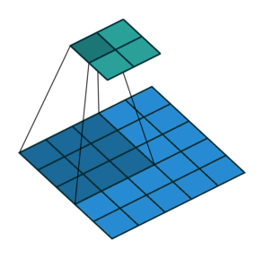
- The convolution of two matrices is a mathematical operation that produces a third matrix. It is commonly used in image processing, where it is used to apply a filter to an image. In this operation, one matrix is used as the filter, and the other matrix is the input data. The result of the convolution is a new matrix, which is the result of applying the filter to the input data.

Program Structure:
The program works in the following manner
- It divides the matrix in 4 quadrants, with 2 threads working on each quadrant (there are 8 threads in total)
- The local result of each thread is stored in a separate file
- The program also stored the convolution matrix, filter matrix and original matrix in separate files.
Technologies used in the Project:
- We used Visual Studio as the IDE for this project.
- The language used in the project was C++
- Openmp library for parallel execution of code.

THE END

